COS10029 Fundamentals of Programming TP 2 2023

Assignment 1 report

Name: Sovithyea Prach Student ID:105270743

Lab class: day / time / room Teacher: Dr. Prince Kurumthodathu
Surendran

Due Date: Monday 5th August 2024 at 11:59 pm

Date Submitted: Wednesday 30th August 2017 at 5:00pm

Question 1

Program description

The primary goal of this C++ software is to request the product code, quantity, and even the total amount of products purchased along with the total cost from the customer. The user may easily and quickly verify the prices for both the individual and total things they have purchased with this program.

Source code:

IMPORTANT: DON’T GIVE THE SCREENSHOT OF THE CODE (COPY AND PASTE THE CODE)

#include <iostream>
using namespace std;

//declaring variables

double calculate_cost(int product, int quantity)
{
switch(product) //for different scenarios (different product codes)
{
case 1:
return 3.25 * quantity;
case 2:
return 1.75 * quantity;
case 3:
return 7.85 * quantity;
case 4:
return 0.35 * quantity;
default:
return 0.0;
}
}

void display_invoice(double total_cost, int total_quantity) //final result
{
cout << "Invoice" << endl;
cout << "Total number of Products: " << total_quantity << endl;
cout << "Total Invoice Amount: $" << total_cost << endl;
}

int main()
{
int product;
int quantity;
double total_cost = 0.0;
int total_quantity = 0;

while (true)
{
cout << "Product Code: "; //asking for product code
cin >> product;

if (product == -1) {
break;
}

if (product < 1 or product > 4)
{
cout << "Error... Invalid Product Code, please enter the code again" << endl; //invalid product code
continue;
}

cout << "Quantity: "; //asking for quantity of products
cin >> quantity;

if (quantity <= 0)
{
cout << "Error... Invalid Quantity, please enter the quantity again" << endl; //invalid quantity
continue;
}

double cost = calculate_cost(product, quantity); //calculating overall cost and overall quantity
total_cost += cost;
total_quantity += quantity;

cout << "Total - $" << cost << endl;
}

display_invoice(total_cost, total_quantity); //displaying final invoice

return 0;
}

Screenshots showing working program (Show all possible outcome):
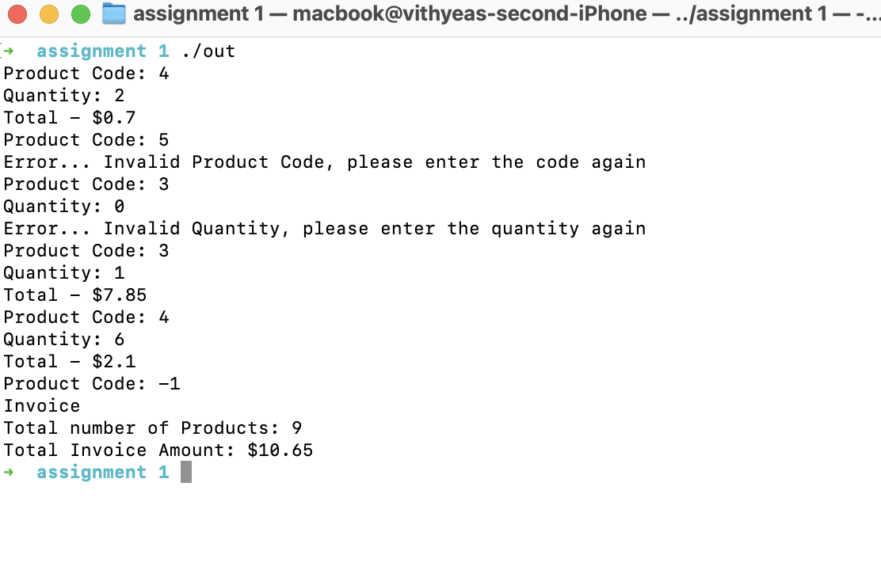

Question 2

Program description

With the help of splash kit and the rand command, our C++ software created a stunning work of art by drawing stars in rows and columns in various colours. The result displays how the diamonds are matched to create a larger triangle shape.

Source code:

IMPORTANT: DON’T GIVE THE SCREENSHOT OF THE CODE (COPY AND PASTE THE CODE)

#include <stdlib.h>
#include <time.h>
#include "splashkit.h"

void draw_star(color clr, double x, double y, int width, int height) //declaring variables to draw a star
{
double x2=x+width;
double y2=y+height;
double left_x=x-width;
double mid_x=x+width/2;
double mid_y=y+height/2;
double bottom_y=y2+height;
double top_y=y-height;
double right_x=x2+width;

switch(rand()%4) //randomizing the colors of the stars
{
case 0: clr = COLOR_RED;
break;
case 1: clr = COLOR_YELLOW;
break;
case 2: clr = COLOR_GREEN;
break;
case 3: clr = COLOR_BLUE;
break;
}
//commands to draw a star
fill_rectangle(clr, x, y, width, height);
fill_triangle(clr, x, y ,x2, y, mid_x, top_y);
fill_triangle(clr, x2,y, x2, y2, right_x, mid_y);
fill_triangle(clr, x2, y2, mid_x, bottom_y, x, y2);
fill_triangle(clr, x, y2, left_x, mid_y, x, y);
}

int main() //splashkit commands
{
open_window("Shape", 800, 600);
clear_screen(COLOR_WHITE);
srand(time(NULL));
int row=1, column, x=100, y=100;

//displaying the coordinates of each star
while(row<=10)
{
column=1;
while(column<=row)
{
draw_star(random_color(), x, y, 10, 10);
x = x + 50;
column++;
}
row++;
x = 100;
y = y + 50;
}
//splashkit commands
refresh_screen(60);
delay(5000);
return 0;
}

Screenshots showing working program (Show all possible outcome):
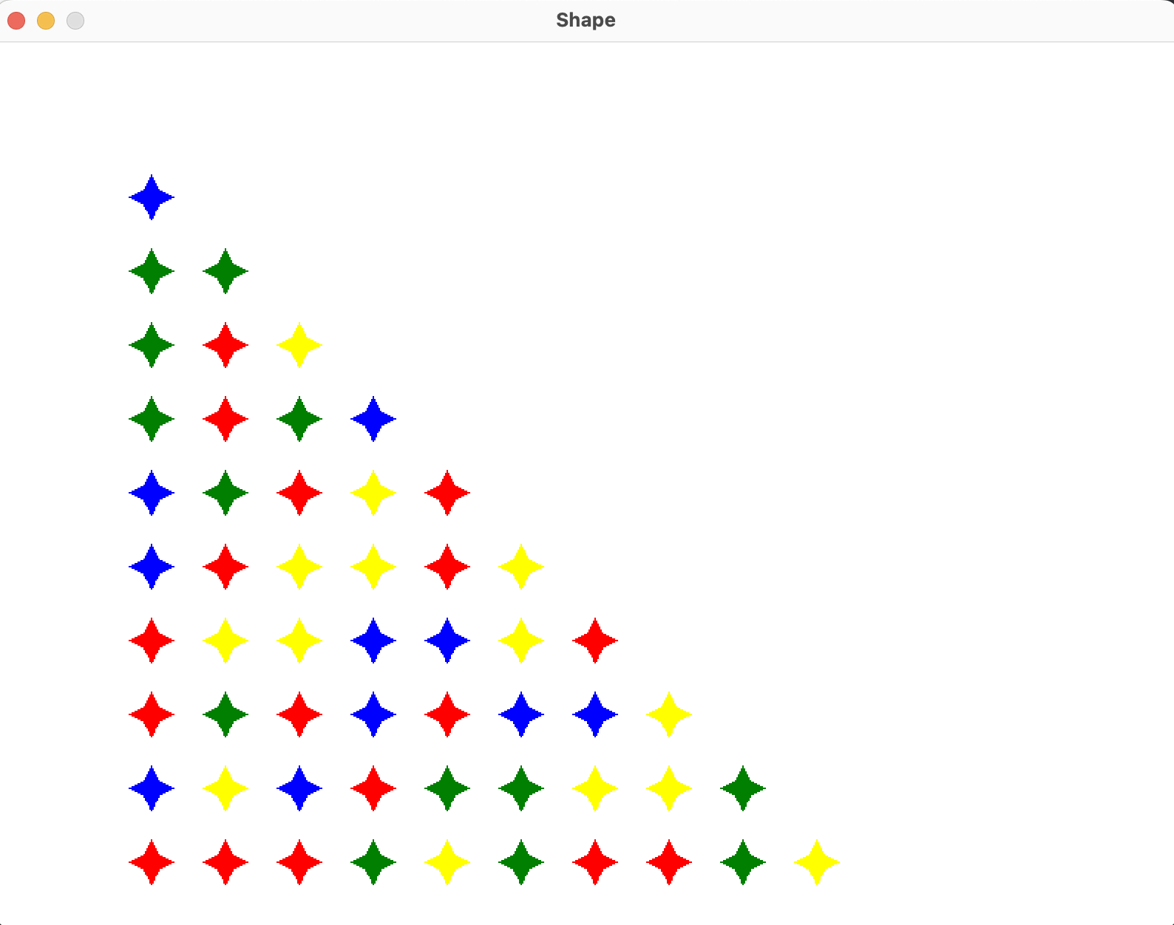

Question 3

Program description

Using the rand command, this software simulates a dice-rolling game. You roll three dice, and the goal is to roll 13 or more to win; if you roll six or fewer, you lose. You have to reroll if you are able to get 15 or more on your first attempt.

Source code:

IMPORTANT: DON’T GIVE THE SCREENSHOT OF THE CODE (COPY AND PASTE THE CODE)

#include <iostream>
#include <cstdlib>
#include <ctime>
using namespace std;

//declaring variables
int point;

int rollDice() //randomizing each dice roll
{
int roll1 = rand() % 6 + 1;
int roll2 = rand() % 6 + 1;
int roll3 = rand() % 6 + 1;
int sum = roll1 + roll2 + roll3;
cout << "Player rolled " << roll1 << " + " << roll2 << " + " << roll3 << " = " << sum << endl;
return sum;
}

void result()
{
int sum = rollDice();
point = sum;
if (sum >= 13) //13 or greater means player wins
{
cout << "Player wins " << endl;
return;
}
else if (sum <= 6) //6 or lower means player loses
{
cout << "Player loses" << endl;
return;
}
else if (sum >= 7 && sum <= 12) //for if sum is between 7 and 12
{
cout << "Point is " << sum << endl;
}
do
{
sum = rollDice();

if (sum == point)
{
cout << "You win!" << endl;
break;
}
else if (sum >= 15) //must roll under 15 to win
{
cout << "You lose due to your sum " << sum << " being greater than or equal to 15 before making the point" << endl;
break;
}
} while (true);
}

int main()
{
srand(time(NULL));
result();
return 0;
}

Screenshots showing working program (Show all possible outcome):
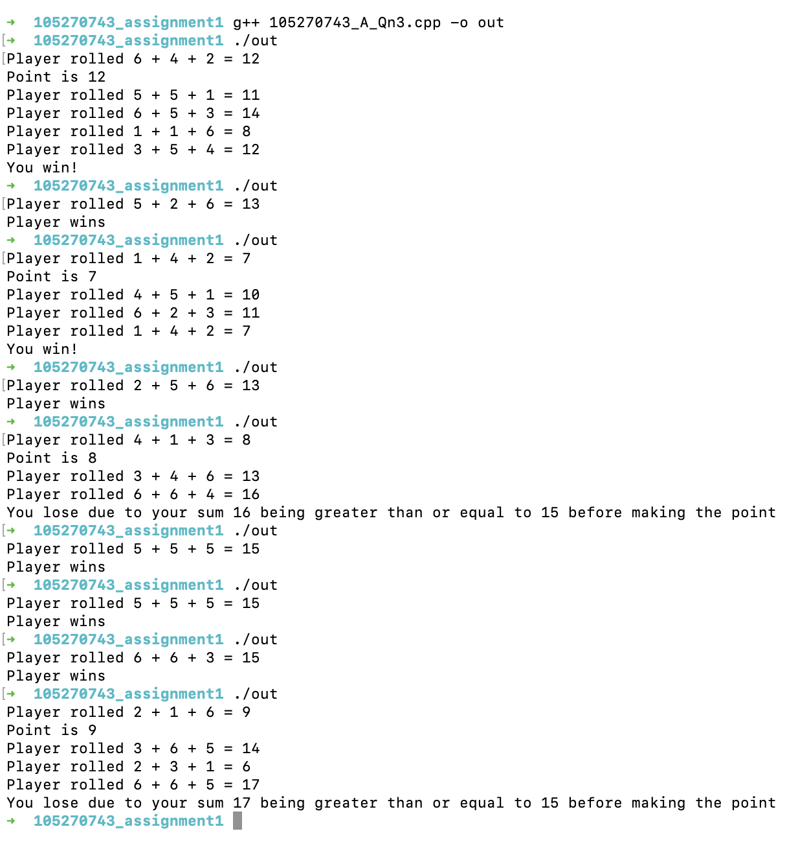

Question 4
Remove the grey text and insert your content.

Program description

With the help of these commands, the user can select a desired shape and colour in this application created by Splashkit, and when they click the "click to draw" button, their preferred shape and colour will display on the screen.

Source code:

#include "splashkit.h"
using namespace std;

// Define the selection areas for shapes
bool choiceSquare = (mouse_x() >= 100) && (mouse_x() <= 175) && (mouse_y() >= 100) && (mouse_y() <= 175);
bool choiceRectangle = (mouse_x() >= 200) && (mouse_x() <= 300) && (mouse_y() >= 100) && (mouse_y() <= 120);
bool choiceCircle = (mouse_x() >= 350) && (mouse_x() <= 375) && (mouse_y() >= 110) && (mouse_y() <= 165);
bool choiceTriangle = (mouse_x() >= 400) && (mouse_x() <= 450) && (mouse_y() >= 100) && (mouse_y() <= 195);

// Define the selection areas for colors
bool choiceBlue = (mouse_x() >= 100) && (mouse_x() <= 175) && (mouse_y() >= 250) && (mouse_y() <= 325);
bool choiceRed = (mouse_x() >= 200) && (mouse_x() <= 275) && (mouse_y() >= 250) && (mouse_y() <= 325);
bool choiceBlack = (mouse_x() >= 300) && (mouse_x() <= 375) && (mouse_y() >= 250) && (mouse_y() <= 325);
bool choiceGreen = (mouse_x() >= 400) && (mouse_x() <= 475) && (mouse_y() >= 250) && (mouse_y() <= 325);

// Define the final area where the shape will be drawn
bool choiceFinal = (mouse_x() >= 100) && (mouse_x() <= 245) && (mouse_y() >= 370) && (mouse_y() <= 410);

void draw_shape()
{
draw_rectangle(COLOR_BLACK, 100, 100, 75, 75);
draw_rectangle(COLOR_BLACK, 200, 100, 100, 20);
draw_circle(COLOR_BLACK, 350, 110, 25);
draw_triangle(COLOR_BLACK, 400, 140, 450, 140, 425, 70);
}

void click_space()
{
if(mouse_down(LEFT_BUTTON))
{
// Define the selection areas for shapes
bool choiceSquare = (mouse_x() >= 100) && (mouse_x() <= 175) && (mouse_y() >= 100) && (mouse_y() <= 175);
bool choiceRectangle = (mouse_x() >= 200) && (mouse_x() <= 300) && (mouse_y() >= 100) && (mouse_y() <= 120);
bool choiceCircle = (mouse_x() >= 350) && (mouse_x() <= 375) && (mouse_y() >= 110) && (mouse_y() <= 165);
bool choiceTriangle = (mouse_x() >= 400) && (mouse_x() <= 450) && (mouse_y() >= 100) && (mouse_y() <= 195);

// Define the selection areas for colors
bool choiceBlue = (mouse_x() >= 100) && (mouse_x() <= 175) && (mouse_y() >= 250) && (mouse_y() <= 325);
bool choiceRed = (mouse_x() >= 200) && (mouse_x() <= 275) && (mouse_y() >= 250) && (mouse_y() <= 325);
bool choiceBlack = (mouse_x() >= 300) && (mouse_x() <= 375) && (mouse_y() >= 250) && (mouse_y() <= 325);
bool choiceGreen = (mouse_x() >= 400) && (mouse_x() <= 475) && (mouse_y() >= 250) && (mouse_y() <= 325);

if(choiceSquare)
{
draw_text("Square", COLOR_BLACK, "Arial.ttf", 100, 670 , 110);
}
if(choiceRectangle)
{
draw_text("Rectangle", COLOR_BLACK, "Arial.ttf", 100, 670 , 110);
}
if(choiceCircle)
{
draw_text("Circle", COLOR_BLACK, "Arial.ttf", 100, 670 , 110);
}
if(choiceTriangle)
{
draw_text("Triangle", COLOR_BLACK, "Arial.ttf", 100, 670 , 110);
}
if(choiceBlue)
{
draw_text("Blue", COLOR_BLUE, "Arial.ttf", 100, 670 , 255);
}
if(choiceRed)
{
draw_text("Red", COLOR_RED, "Arial.ttf", 100, 670 , 255);
}
if(choiceBlack)
{
draw_text("Black", COLOR_BLACK, "Arial.ttf", 100, 670 , 255);
}
if(choiceGreen)
{
draw_text("Green", COLOR_GREEN, "Arial.ttf", 100, 670 , 255);
}
}
}

void choose_color()
{
fill_rectangle(COLOR_BLUE, 100, 250, 75, 75);
fill_rectangle(COLOR_RED, 200, 250, 75, 75);
fill_rectangle(COLOR_BLACK, 300, 250, 75, 75);
fill_rectangle(COLOR_GREEN, 400, 250, 75, 75);
}

void boxes()
{
draw_rectangle(COLOR_BLACK, 600, 100, 145, 60);
draw_rectangle(COLOR_BLACK, 600, 250, 145, 60);
draw_rectangle(COLOR_BLACK, 100, 370, 145, 40);
fill_triangle(COLOR_BLACK, 500, 240, 550, 240, 525, 170);
}

void draw_shapeFinal()
{

if(mouse_down(LEFT_BUTTON))
{
// Define the final area where the shape will be drawn
bool choiceFinal = (mouse_x() >= 100) && (mouse_x() <= 245) && (mouse_y() >= 370) && (mouse_y() <= 410);

if(choiceFinal)

if(choiceBlue && choiceSquare)
{
fill_rectangle(COLOR_BLUE, 500, 300, 100, 100);
}
if(choiceBlue && choiceRectangle)
{
fill_rectangle(COLOR_BLUE, 500, 300, 100, 20);
}
if(choiceBlue && choiceCircle)
{
fill_circle(COLOR_BLUE, 500, 300, 20);
}
if(choiceBlue && choiceTriangle)
{
fill_triangle(COLOR_BLUE, 500, 240, 550, 240, 525, 170);
}
if(choiceRed && choiceSquare)
{
fill_rectangle(COLOR_RED, 500, 300, 100, 100);
}
if(choiceRed && choiceRectangle)
{
fill_rectangle(COLOR_RED, 500, 300, 100, 20);
}
if(choiceRed && choiceCircle)
{
fill_circle(COLOR_RED, 500, 300, 20);
}
if(choiceRed && choiceTriangle)
{
fill_triangle(COLOR_RED, 500, 240, 550, 240, 525, 170);
}
if(choiceBlack && choiceSquare)
{
fill_rectangle(COLOR_BLACK, 500, 300, 100, 100);
}
if(choiceBlack && choiceRectangle)
{
fill_rectangle(COLOR_BLACK, 500, 300, 100, 20);
}
if(choiceBlack && choiceCircle)
{
fill_circle(COLOR_BLACK, 500, 300, 20);
}
if(choiceBlack && choiceTriangle)
{
fill_triangle(COLOR_BLACK, 500, 240, 550, 240, 525, 170);
}
if(choiceGreen && choiceSquare)
{
fill_rectangle(COLOR_GREEN, 500, 300, 100, 100);
}
if(choiceGreen && choiceRectangle)
{
fill_rectangle(COLOR_GREEN, 500, 300, 100, 20);
}
if(choiceGreen && choiceCircle)
{
fill_circle(COLOR_GREEN, 500, 300, 20);
}
if(choiceGreen && choiceTriangle)
{
fill_triangle(COLOR_GREEN, 500, 240, 550, 240, 525, 170);
}

}
}

int main()
{
open_window("Button click", 800, 600);
clear_screen(COLOR_WHITE);

while(not quit_requested())
{
draw_shape();
click_space();
choose_color();
boxes();
draw_shapeFinal();
draw_text("Shape: ", COLOR_BLACK, "Arial.ttf", 50, 610, 110);
draw_text("Color: ", COLOR_BLACK, "Arial.tff", 50, 610, 255);
draw_text("Click to draw", COLOR_BLACK, "Arial.ttf", 50, 110, 385);

process_events();
refresh_screen(60);
}
return 0;
}
#include "splashkit.h"
using namespace std;

// Define the selection areas for shapes
bool choiceSquare = (mouse_x() >= 100) && (mouse_x() <= 175) && (mouse_y() >= 100) && (mouse_y() <= 175);
bool choiceRectangle = (mouse_x() >= 200) && (mouse_x() <= 300) && (mouse_y() >= 100) && (mouse_y() <= 120);
bool choiceCircle = (mouse_x() >= 350) && (mouse_x() <= 375) && (mouse_y() >= 110) && (mouse_y() <= 165);
bool choiceTriangle = (mouse_x() >= 400) && (mouse_x() <= 450) && (mouse_y() >= 100) && (mouse_y() <= 195);

// Define the selection areas for colors
bool choiceBlue = (mouse_x() >= 100) && (mouse_x() <= 175) && (mouse_y() >= 250) && (mouse_y() <= 325);
bool choiceRed = (mouse_x() >= 200) && (mouse_x() <= 275) && (mouse_y() >= 250) && (mouse_y() <= 325);
bool choiceBlack = (mouse_x() >= 300) && (mouse_x() <= 375) && (mouse_y() >= 250) && (mouse_y() <= 325);
bool choiceGreen = (mouse_x() >= 400) && (mouse_x() <= 475) && (mouse_y() >= 250) && (mouse_y() <= 325);

// Define the final area where the shape will be drawn
bool choiceFinal = (mouse_x() >= 100) && (mouse_x() <= 245) && (mouse_y() >= 370) && (mouse_y() <= 410);

void draw_shape()
{
draw_rectangle(COLOR_BLACK, 100, 100, 75, 75);
draw_rectangle(COLOR_BLACK, 200, 100, 100, 20);
draw_circle(COLOR_BLACK, 350, 110, 25);
draw_triangle(COLOR_BLACK, 400, 140, 450, 140, 425, 70);
}

void click_space()
{
if(mouse_down(LEFT_BUTTON))
{
// Define the selection areas for shapes
bool choiceSquare = (mouse_x() >= 100) && (mouse_x() <= 175) && (mouse_y() >= 100) && (mouse_y() <= 175);
bool choiceRectangle = (mouse_x() >= 200) && (mouse_x() <= 300) && (mouse_y() >= 100) && (mouse_y() <= 120);
bool choiceCircle = (mouse_x() >= 350) && (mouse_x() <= 375) && (mouse_y() >= 110) && (mouse_y() <= 165);
bool choiceTriangle = (mouse_x() >= 400) && (mouse_x() <= 450) && (mouse_y() >= 100) && (mouse_y() <= 195);

// Define the selection areas for colors
bool choiceBlue = (mouse_x() >= 100) && (mouse_x() <= 175) && (mouse_y() >= 250) && (mouse_y() <= 325);
bool choiceRed = (mouse_x() >= 200) && (mouse_x() <= 275) && (mouse_y() >= 250) && (mouse_y() <= 325);
bool choiceBlack = (mouse_x() >= 300) && (mouse_x() <= 375) && (mouse_y() >= 250) && (mouse_y() <= 325);
bool choiceGreen = (mouse_x() >= 400) && (mouse_x() <= 475) && (mouse_y() >= 250) && (mouse_y() <= 325);

if(choiceSquare)
{
draw_text("Square", COLOR_BLACK, "Arial.ttf", 100, 670 , 110);
}
if(choiceRectangle)
{
draw_text("Rectangle", COLOR_BLACK, "Arial.ttf", 100, 670 , 110);
}
if(choiceCircle)
{
draw_text("Circle", COLOR_BLACK, "Arial.ttf", 100, 670 , 110);
}
if(choiceTriangle)
{
draw_text("Triangle", COLOR_BLACK, "Arial.ttf", 100, 670 , 110);
}
if(choiceBlue)
{
draw_text("Blue", COLOR_BLUE, "Arial.ttf", 100, 670 , 255);
}
if(choiceRed)
{
draw_text("Red", COLOR_RED, "Arial.ttf", 100, 670 , 255);
}
if(choiceBlack)
{
draw_text("Black", COLOR_BLACK, "Arial.ttf", 100, 670 , 255);
}
if(choiceGreen)
{
draw_text("Green", COLOR_GREEN, "Arial.ttf", 100, 670 , 255);
}
}
}

void choose_color()
{
fill_rectangle(COLOR_BLUE, 100, 250, 75, 75);
fill_rectangle(COLOR_RED, 200, 250, 75, 75);
fill_rectangle(COLOR_BLACK, 300, 250, 75, 75);
fill_rectangle(COLOR_GREEN, 400, 250, 75, 75);
}

void boxes()
{
draw_rectangle(COLOR_BLACK, 600, 100, 145, 60);
draw_rectangle(COLOR_BLACK, 600, 250, 145, 60);
draw_rectangle(COLOR_BLACK, 100, 370, 145, 40);
}

void draw_shapeFinal()
{

if(mouse_down(LEFT_BUTTON))
{
// Define the final area where the shape will be drawn
bool choiceFinal = (mouse_x() >= 100) && (mouse_x() <= 245) && (mouse_y() >= 370) && (mouse_y() <= 410);

if(choiceFinal)

if(choiceBlue && choiceSquare)
{
fill_rectangle(COLOR_BLUE, 500, 300, 100, 100);
}
if(choiceBlue && choiceRectangle)
{
fill_rectangle(COLOR_BLUE, 500, 300, 100, 20);
}
if(choiceBlue && choiceCircle)
{
fill_circle(COLOR_BLUE, 500, 300, 20);
}
if(choiceBlue && choiceTriangle)
{
fill_triangle(COLOR_BLUE, 500, 240, 550, 240, 525, 170);
}
if(choiceRed && choiceSquare)
{
fill_rectangle(COLOR_RED, 500, 300, 100, 100);
}
if(choiceRed && choiceRectangle)
{
fill_rectangle(COLOR_RED, 500, 300, 100, 20);
}
if(choiceRed && choiceCircle)
{
fill_circle(COLOR_RED, 500, 300, 20);
}
if(choiceRed && choiceTriangle)
{
fill_triangle(COLOR_RED, 500, 240, 550, 240, 525, 170);
}
if(choiceBlack && choiceSquare)
{
fill_rectangle(COLOR_BLACK, 500, 300, 100, 100);
}
if(choiceBlack && choiceRectangle)
{
fill_rectangle(COLOR_BLACK, 500, 300, 100, 20);
}
if(choiceBlack && choiceCircle)
{
fill_circle(COLOR_BLACK, 500, 300, 20);
}
if(choiceBlack && choiceTriangle)
{
fill_triangle(COLOR_BLACK, 500, 240, 550, 240, 525, 170);
}
if(choiceGreen && choiceSquare)
{
fill_rectangle(COLOR_GREEN, 500, 300, 100, 100);
}
if(choiceGreen && choiceRectangle)
{
fill_rectangle(COLOR_GREEN, 500, 300, 100, 20);
}
if(choiceGreen && choiceCircle)
{
fill_circle(COLOR_GREEN, 500, 300, 20);
}
if(choiceGreen && choiceTriangle)
{
fill_triangle(COLOR_GREEN, 500, 240, 550, 240, 525, 170);
}

}
}

int main()
{
open_window("Button click", 800, 600);
clear_screen(COLOR_WHITE);

while(not quit_requested())
{
draw_shape();
click_space();
choose_color();
boxes();
draw_shapeFinal();
draw_text("Shape: ", COLOR_BLACK, "Arial.ttf", 50, 610, 110);
draw_text("Color: ", COLOR_BLACK, "Arial.tff", 50, 610, 255);
draw_text("Click to draw", COLOR_BLACK, "Arial.ttf", 50, 110, 385);

process_events();
refresh_screen(60);
}
return 0;
}

IMPORTANT: DON’T GIVE THE SCREENSHOT OF THE CODE (COPY AND PASTE THE CODE)

Copy the code from visual studio or text editor you are using and paste it here

Screenshots showing working program (Show all possible outcome):

